**Alter Stream User Guide**

**About The Program**

The program runs on transport stream (.ts) files. It has multiple functionalities, all functionalities are to do with inserting or replacing data and altering the PMTs of services. The following main functions can be used:

* Replace SCTE with DSMCC
* Insert AIT
* Replace SCTE with DSMCC and Insert AIT
* Insert DSMCC data

**Using The Program**

To run the program, from the command line in the directory containing the alterStream.py file, run with:

*python alterStream.py “filename”*

The filename will be accepted with or without the .ts extension.

From then, a series of integer based choices will be presented to the user, use the integer keys to select an option and enter to confirm.

Some options will have text inputs.

**Program Limitations**

The program only runs one service and one function at a time, if more than one service or function is required to be used, the user must go through the program and then select “another channel” at the end however many times it takes to complete the altering process.

**Program Flow**

The following will describe the program flow for the program from start to finish, all options included:

* **Service Choice** a list of available services within the stream will come up and can be chosen using the corresponding index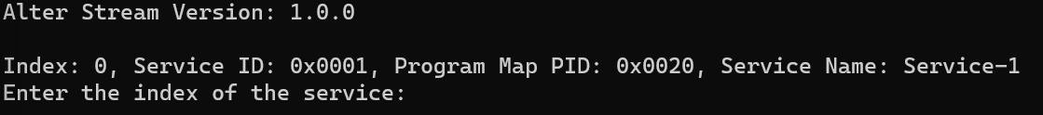
* **Process Choice** the process that is required can now be chosen with the index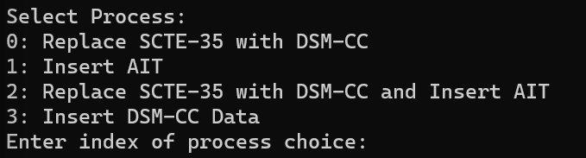
* **Replace SCTE35 with DSMCC**
  + **Null SCTE Choice** The option to replace null SCTE with DSMCC, or instead insert null packets

* + The replacement will then be completed, and the PMT altered,
  + **Add DSMCC Element Choice** the option to add the DSMCC element to another service will then be presentedA screenshot of a computer program

    Description automatically generated
  + If yes, the services will again be listed to choose which service to add to.
  + **Another Channel Choice** after this, the option to do another channel will be presented, this is where the current stream can be edited further. A black background with white text

    Description automatically generated
* **Insert AIT** inserts an AIT to the service, for all *default* parts, leaving the input blank uses the default
  + **From XML** uses an XML file of an AIT to insert**A screen shot of a computer program

    Description automatically generated**
  + **ManualA screenshot of a computer program

    Description automatically generated**
  + **Another Channel Choice** after this, the option to do another channel will be presented, this is where the current stream can be edited further.
* **Replace SCTE35 and Insert AIT**
  + A combination of the above 2 options, one after the other.
* **Insert DSMCC Data**
  + **Insertion Period Choice** is where the integer value of the insertion period can be chosen, i.e., how far apart insertions are in the stream 
  + **Jitter Choice** 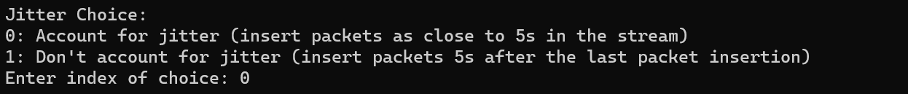
    - Account for jitter means that packets will be inserted in the stream as close to the interval as possible, it does not compound upon not finding a null packet to replace immediately, if the insertion period is 5s, the packets will be inserted as close to 5,10,15 seconds as possible.
    - Don’t account for jitter means that the next packet will be inserted as close to the interval after the previous packet, so if the interval was 5s, but the packet was inserted at 6s as this was as close as it could get, the next one would be inserted as close to 11s as possible
  + **Data Choice** is where the data that will be in the packets can be chosen, at the moment can just be the date or a packet count iterator, but more can be added. A black background with white dots

    Description automatically generated
  + **PID Choice** Can choose the desired PID, if not available will find a suitable one



* + The output from the packet insertion will be printed A screen shot of a computer

    Description automatically generated
  + **Another Channel Choice** after this, the option to do another channel will be presented, this is where the current stream can be edited further.